Task 3A: Fieldwork Booklet
Weighting: 2.5% Total: _______________________/ 107




Fire Geography
Investigating the impact of fire on our environment

Recommended for ATAR Geography Unit 1: Natural Hazards General Geography Unit 3: Natural Hazards

EXCURSION WORKSHEETS
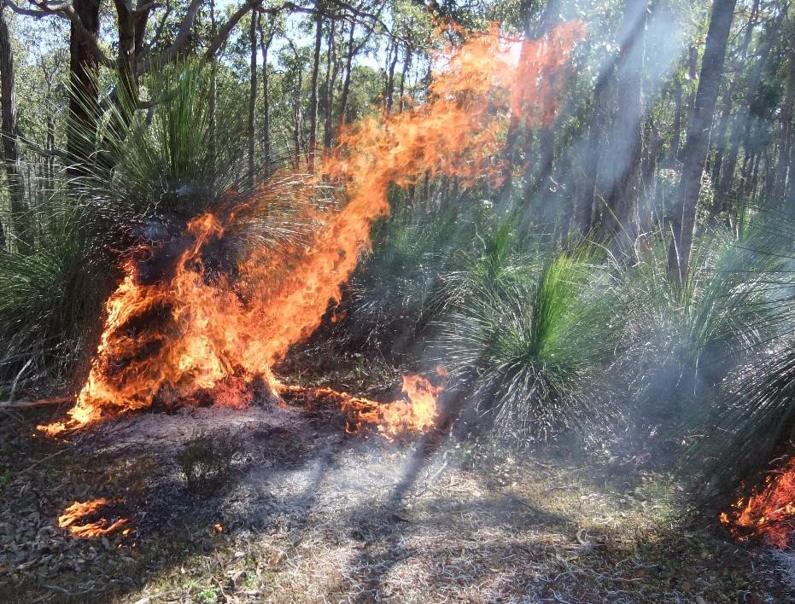


Student Name - ……………………………………………………………………………………………
Please minimise your impact on the ecosystem by not dropping litter, removing or damaging plants. Please take care where you step.

Introduction
- Fire is a natural hazard. List the impacts a high intensity fire can have on the natural environment: (3 marks)

- The Fire Triangle: Draw and describe the fire triangle: (3 marks)

3a. What management strategy is carried out to reduce the risk or spread of bushfires? (1 mark)

3b. How does this strategy reduce bushfire risk? (2 marks)

- Risk management: (6 marks)

List some of the hazards (risks) residents and firefighters face during a fire : | List the fire fighting equipment that is used to manage a fire:

- Mitigation strategies: Explain how helitaks and fixed wing bombers aid in fire suppression: (2 marks)

House ignition sources: (3 marks)
Page2

a. What are the two main ignition sources for a house within a fire zone? | b. Which one of these two sources do residents have some control over?
1.
2.

Scenario mapping
(15 marks)

We are going to use your skills in mapping to plot an actual fire front that happened in this area on the 14/01/2018 at 09:00

  - Mark a X for the ignition point at AR 76 44. Label it IP

  - Starting at 09:00 work out the rate of spread for your fire in metres per hour and use the map distance scale to work out how far it would have travelled in millimetres.

  - Using a ruler draw a line, mark the fire front distance and with your drawing knowledge of fire behaviour from the pre-excursion mark the fire shape in the first hour.

  - Annotate the time at the ignition point, the front of the fire and the fire flanks

  - What assets are you aware of in front of this fire at this time? …………………………………….

……………………………………………………………………………………………….………………………….

  - Repeat for hours two, three, four and five. Don’t forget fires don’t always go exactly
forward.

  - What assets may be threatened by this fire? …………………………………………………………

…………………………………………………………………………………………………………………………...

  - What could be done to protect these assets? ………………………………………………………

…………………………………………………………………………………………………………………………...

Looking at your fire map you created, and the other groups in the class, how well does it match with the actual fire boundary? What is your estimate of the actual fuel age where the fire burnt?

…………………………………………………………………………………………………………………………...

…………………………………………………………………………………………………………………………...

…………………………………………………………………………………………………………………………...

How much do you think the younger fuel age areas influenced the fire shape?

…………………………………………………………………………………………………………………………...

…………………………………………………………………………………………………………………………...
Page3

l'OO"E 422 OOOmE 424 OOOmE Joins Map 60 426 OOOmE 428 OOOmE 116°1S'OO"E 430 OOOmE

432 OOOmE

MAP68

C
0
0
0
CD
co
· ·
(0

0
0
0
sc;·
CD
,i-
co

z
E
0
0
0
C\J
(0
"c'o"

0)
(0
n
{1)

(/)
C
·5

0
co

428 OOOmE

0
0
0
0
Ccc\I,

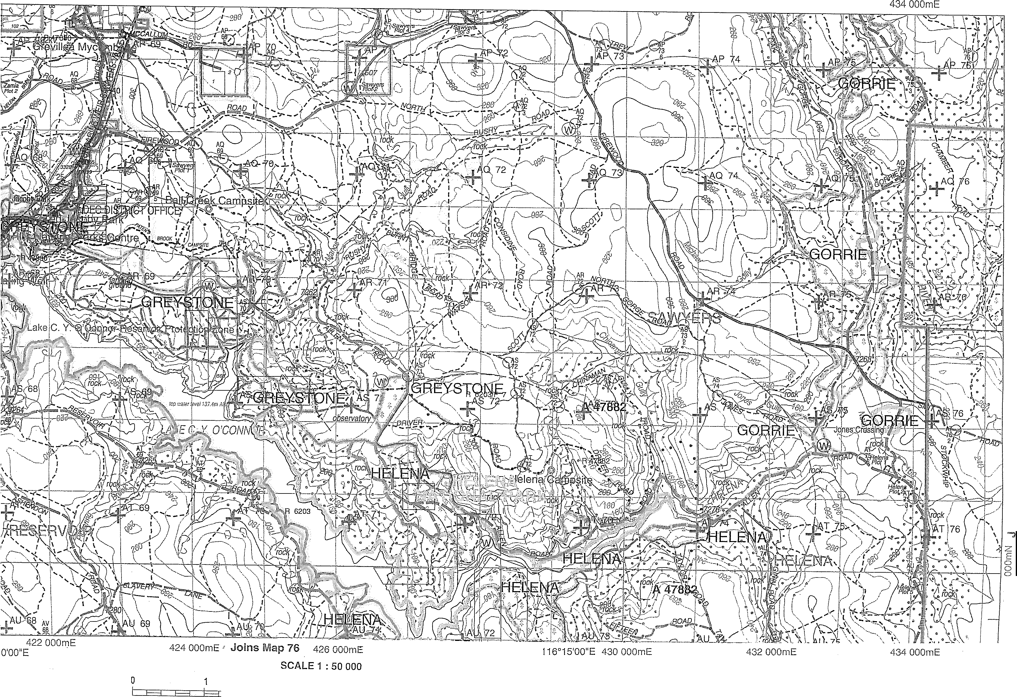
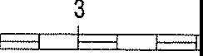
2
F3 Ed E-3
4
Ed E--1
5
E-----3 b-----3 E--1
6
Ed E--1
7
E--1 6 E--1
8
Ed E--1 E-----3 F-------3 E--1
10 kilometres
Ed

Field work
Site 1: Type of fire = Long Unburnt
Location: Perth Hills Discovery Centre Date of fire: N/A

Activity 1: Carry out fuel load and canopy measurements :

 | Recordings |  |  |  |  | Average
Fuel Load (6) | mm mm mm mm  mm Average = mm |  |  |  |  | tonnes/Ha  (1)
Canopy Cover  (5) |  |  |  |  |  | Canopy cover =  %  (1)





Activity 2 : Make general observations of the whole area : (3 marks)

Slope Aspect (direction slope is facing)  ……..… degrees (compass direction). | Circle the direction on the compass
Topographic Slope (use inclinometer) Slope = ……………. degrees

Activity 3 : Make a sketch of the forest profile. Label your sketch (scorch height, fresh re-growth, plant names etc..): (4 marks)
Tree height
If a fire started in this fuel loading what intensity fire would you anticipate? (1 mark)
(circle) High \Low
Considering the three “ingredients” for the fire triangle, which do we have a chance of managing
in the natural environment? (1 mark)

………………………………………………………………………………………………………………………….....

Field Work
Page6
Site 2: Type of fire = ……………………………………………………………….………..(1)
Location: Perth Hills Discovery Centre Date of fire:…………………..…………(1)
Activity 1: Carry out fuel load and canopy measurements:
 | Recordings |  |  |  |  | Average
Fuel Load  (6) | mm mm mm mm  mm Average = mm |  |  |  |  | tonnes/Ha  (1)
Canopy Cover  (5) |  |  |  |  |  | Canopy cover =  %  (1)





Activity 2 : Make general observations of the whole area : (3 marks)
Height of tree scorch (circle) 25% 50% 75% 100%  Or, average height in metres:  ………m | Slope Aspect (direction slope is facing)  ……..… degrees (compass direction).  Circle the direction on the compass
Topographic Slope (use inclinometer) Slope = ……………. degrees

Activity 3 : Make a sketch of the forest profile. Label your sketch (scorch height, fresh re-growth, plant names etc..): (4 marks)
Tree height
What assets will be protected by this burn?

Why wasn’t the whole area burnt in one burn?
(3 marks )

Building Assessment

Name of Building :
What is the building made of?

- Brick
- Timber
- Metal
- Other
Water :
- Is there a hose attached to any of the taps ? Yes / No
- Do you think water will be available if the power goes out?
Which of the following best describes the area around this building :
- Mostly cleared/bare ground
- Low shrubs and gardens
- Mostly green grass
- Forest or bushland
Page7

(10 marks)

How safe do you think this area is if there was a bushfire?

VERY SAFE OK NOT VERY SAFE DANGEROUS
List 3 things you could do around this building to reduce the risk from fire:

1

2

3

Centre Fire Safety Plan
Page8

(15 marks)

Using your knowledge from your building assessment list some steps that can be taken to improve the fire safety of the Centre as a whole, not just buildings?

Preparedness

1 ………………………………………………………………………………………………………………….

2 ………………………………………………………………………………………………………………….

3 ………………………………………………………………………………………………………………….

4 ………………………………………………………………………………………………………………….

5 …………………………………………………………………………………………………………………..

Mitigation

6 ………………………………………………………………………………………………………………….

7 ………………………………………………………………………………………………………………….

8 ………………………………………………………………………………………………………………….

9 ………………………………………………………………………………………………………………….

10 ………………………………………………………………………………………………………………….

Prevention

11 ……………………………………………………………………………………………………………….…

12 ………………………………………………………………………………………………………………….

13 ………………………………………………………………………………………………………………….

14 ……………………………………………………………………………………………………………….…

15 ………………………………………………………………………………………………………………….

Download a fire safety template from https://www.dfes.wa.gov.au/

